



Technical Sheet For
KNX Universal Dimming Actuator,2-Fold
KNX Universal Dimming Actuator,4-Fold

LC-DM02-TP
LC-DM04-TP

The worldwide STANDARD for home and building control
CHARACTERISTICS
- Switch, Relative dimming/Absolute dimming
- Status feedback of switch, brightness, as well as abnormal status (short-circuit, over-voltage, over- temperature and operating voltage failure)
- Reset behaviour after download/bus failure/bus recovery
- 6 dimming curves, including Linear, Exponential, Cubic, Quadratic, Logarithmic, Root and User defined curves
- Leading edge/Trailing edge phase cut dimming
- Manual operation and Output indication function
- Central control function (Only apply for 2/4-fold)
- Individual or parallel output (Parallel can expand the load capacity, only apply for 2/4-fold)
- Staircase lighting, Flashing switch and Delay switch, as well as Scene, Threshold, Forced operation, Safety operation and Operation hours counter
- Logic function, with AND, OR, XOR, Gate forwarding, Threshold comparator, Format convert, Gate function, Delay function and Staircase lighting
- Support the KNX Data Secure

PARAMETERS
Power supply | Bus voltage | 21-30V DC，via the KNX bus
 | Bus current | <7mA/24V, <6mA/30V (2 fold)
 |  | <7.5mA/24V, <6.5mA/30V (4 fold)
 | Bus consumption | <180mW (2 fold)
 |  | <195mW (4 fold)
Output | Dimming channel | 2/4 folds, separate phase connection
 | Max. output capacity | 300W (per channel, Incandescent/ Halogen/ LED, trailing edge)
Parallel: 2 channels 500W /
3 channels 750W/ 4 channel 1000W
 | U_{n} rated voltage | 110~230 V AC (50/60HZ)
 | Protection | Short-circuit, Over-voltage, Over-temperature
 | Standby loss | Approx. 0.7W
 | Power loss | ≤2W / per channel
Connection | KNX | Bus connection terminals
 | Outputs | Screw terminals
 | Wire Range | 0.2—2.5mm² (1 fold)  0.2—6.0mm² (2/4 fold)
Operation and display | Programming button and Red LED | For assigning the physical address
 | Green LED flashing | For displaying application layer running normally
 | Channel button | For manual switching or dimming
 | Channel indication LED | Indicates channel status of the load
 | Man./Auto. button | Change the Man./Auto. mode
 | Man./Auto. LED | Indicate the Man./Auto. mode status
Temperature | Operation | –5 °C ... + 45 °C
 | Storage | –25 °C ... + 55 °C
 | Transport | – 25 °C ... + 70 °C
Environment | Humidity | <93%, except dewing
Mounting | On 35mm mounting rail
DIMENSIONS

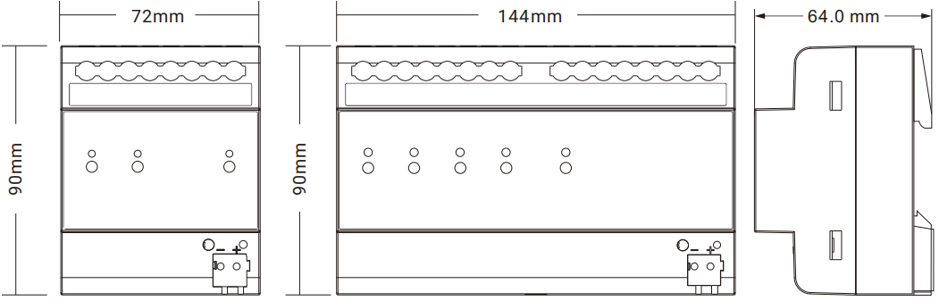

Model | Dimension | Weight
LC-DM02-TP  LC-DM04-TP | 72 x 90 x 64 mm  144 x 90 x 64 mm | 0.3kg  0.5kg
DESCRIPTIONS
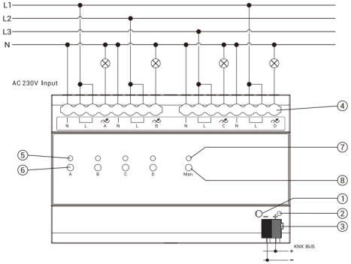  Individual 4 channels | 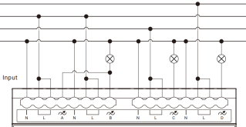  Parallel with 2 channels  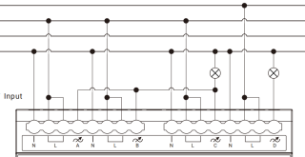  Parallel with 3 channels
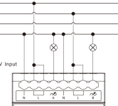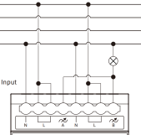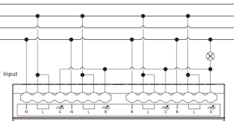
Individual 2 channels Parallel with 2 channels Parallel with 4 channels
①Programming button ②Programming LED
③KNX bus connection terminal ④Input, Output, load terminal
⑤Channel indication LED: in normal mode, LED off is the lamp off, LED on is the lamp on; in manual mode, flashing slowly is dimming manually. Flashing fast is channel abnormality (Short-circuit, Over-voltage, Over-temperature, Operating voltage failure)
⑥Channel button: when no ETS configuration, press to switch on/off; in manual mode, short press to switch on/off, long press for dimming up/down, long press then release to stop dimming
⑦⑧Man./Auto. operation switch button and status indicating LED:
Long press to switchover Man. and Auto. mode, LED on is Man. mode and off is Auto. mode.
Reset the device to the factory configuration: press the programming button and hold for 4 seconds then release, repeat the operation for 4 times, and the interval between each operation is less than 3 seconds

INSTALLATION FIGURE
The devices are suitable for installation on the distribution boards with 35mm DIN rail which complies with DIN EN 60715 in order to facilitate quick installation of the device. Must ensure that the device operation, testing, detecting, maintenance correctly.
IMPORTANT INFORMATION
Installation and commissioning of the device may only be carried out by trained electricians. The relevant standards, directives, regulations and instructions must be observed when planning and implementing the electrical installation.
●Protect the device against moisture, dirt and damage during transport, storage and operation!
●Do not operate the device outside the specified technical data (e.g. temperature range)!
●The device may only be operated in closed enclosures (e.g. wring box).
Should the device become soiled, it may be cleaned with a dry cloth. If this does not suffice, a cloth lightly moistened with soap solution may be used. On no account should caustic agents or solvents be used.

